|  |
| --- |
| Group 1 |
| Controlled Environment Monitors |
| Manufacturing Document ( June 19 ) |

Contents

Sensor Unit Manufacture 1

Enclosure 1

Components 2

Top Cover 2

Bottom Cover 5

Battery Cover 7

Battery Lock 9

Display Unit Enclosure 10

Sensor Unit PCB Manufacture 11

Bill of Materials 11

External Component Bill of Materials 11

Circuit Schematics 12

Circuit Layout 16

PCB Manufacture Additional Information 17

PCB Testing Information 19

Display Unit PCB Manufacture 20

Bill of Materials 20

External Component Bill of Materials 20

Circuit Schematics 21

Circuit Layout 27

PCB Manufacture Additional Information 28

PCB Testing Information 30

Sensor Unit Assembly 31

Assembly Steps 31

Display Unit Assembly 32

Assembly Steps 32

# Sensor Unit Manufacture

## Enclosure

Sensor Unit

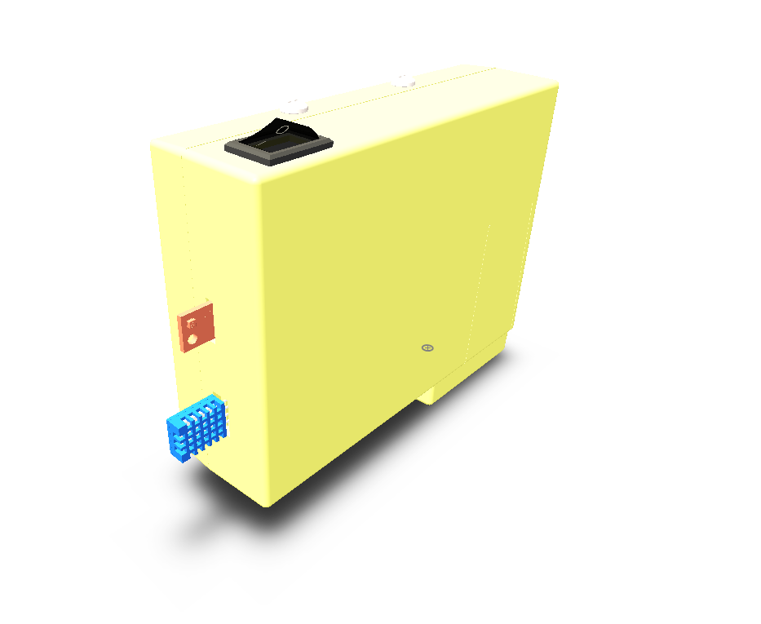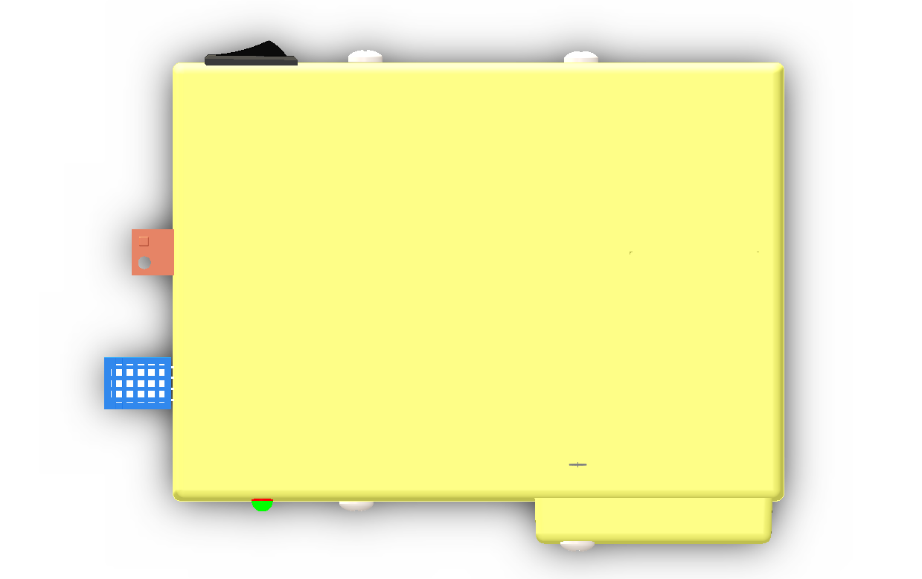

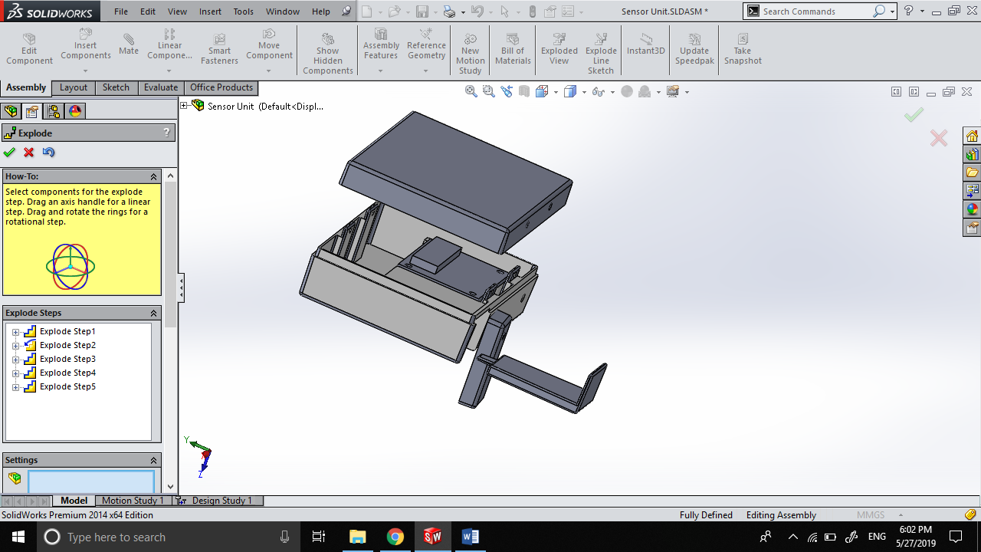

### Components

The Sensor Unit Enclosure consists of 4 components that are to be manufactured by injection molding. All units are to be molded using hard plastic

Components to be molded are:

1. Top Cover
2. Bottom Cover
3. Battery Cover
4. Battery Lock

### Top Cover

#### Draft Analysis

#### Mold Components

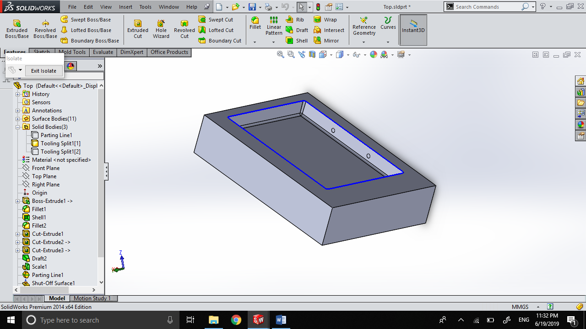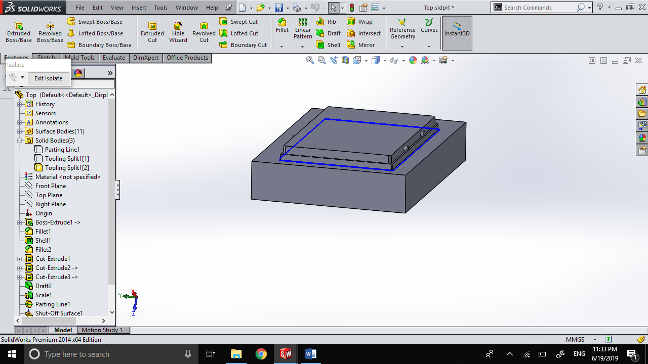

Core

Cavity

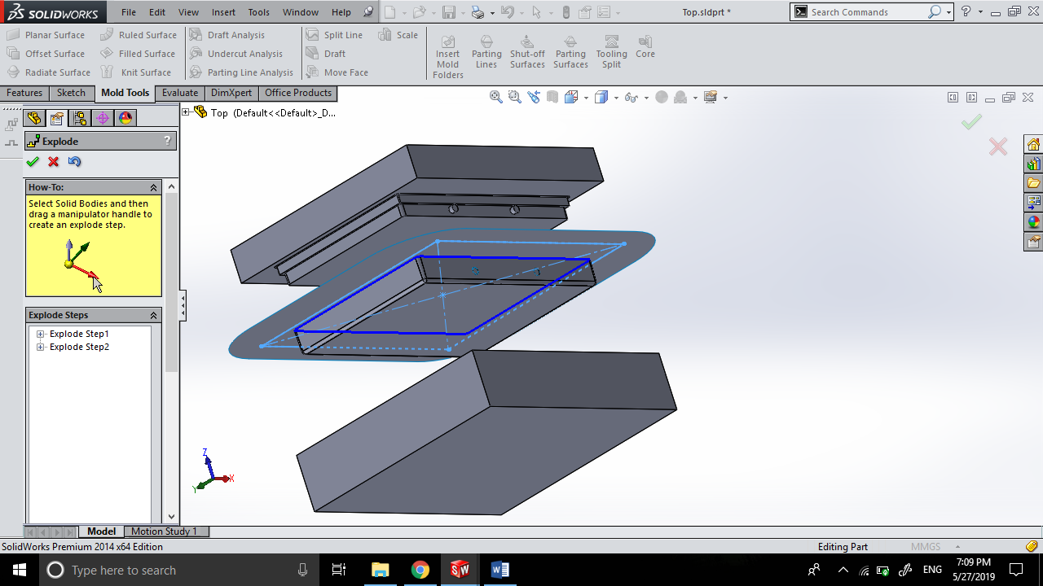

Exploded View of Mold

### Bottom Cover

#### Draft Analysis

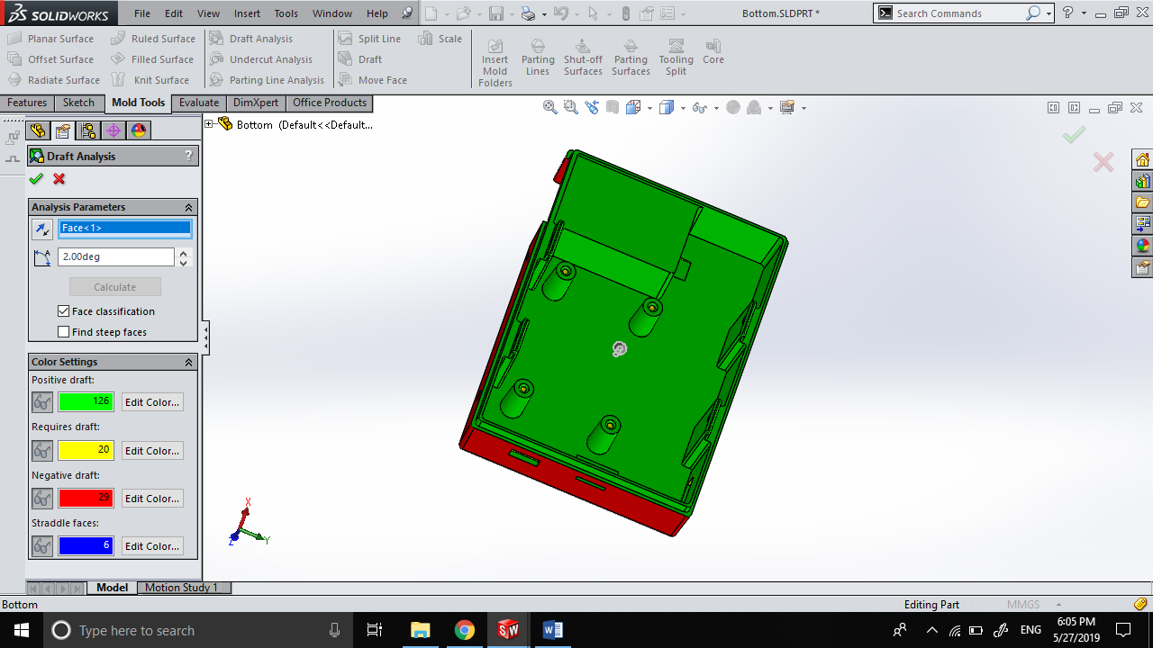

#### Mold Components

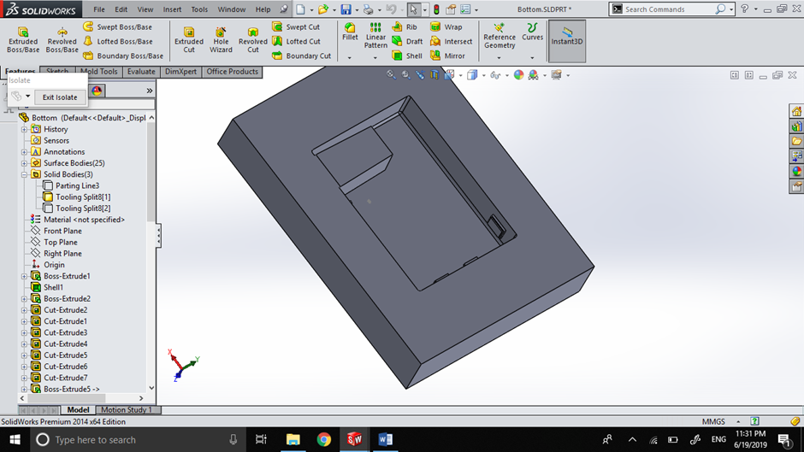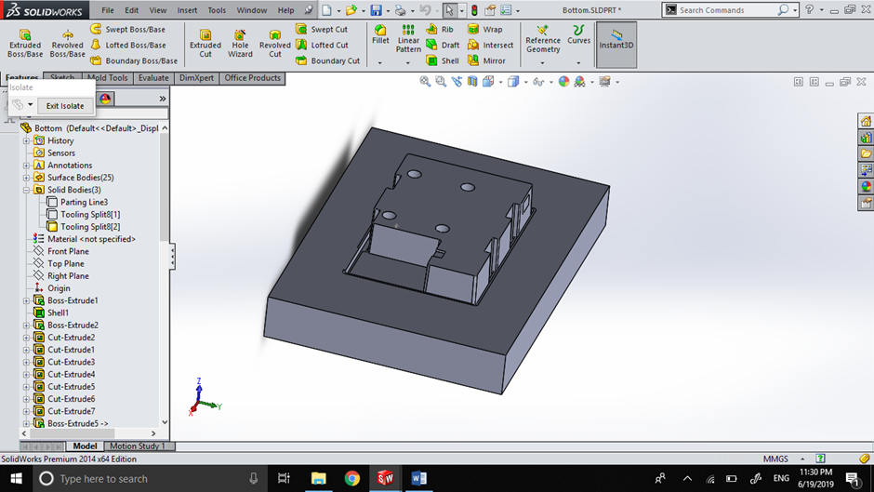

Core

Cavity

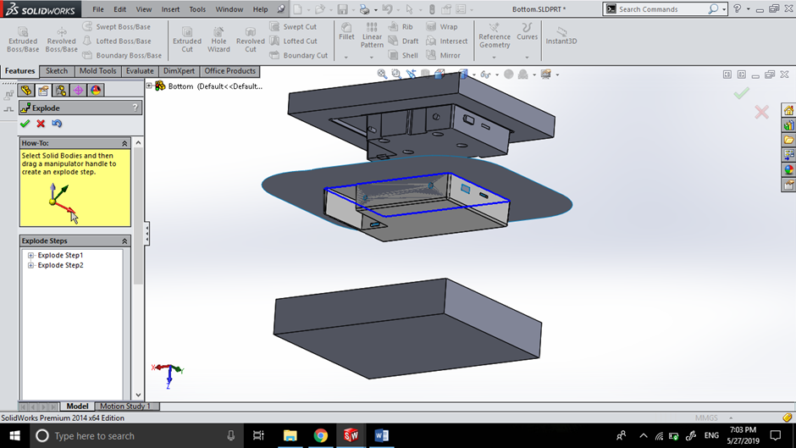

Exploded View of Mold

### Battery Cover

#### Draft Analysis

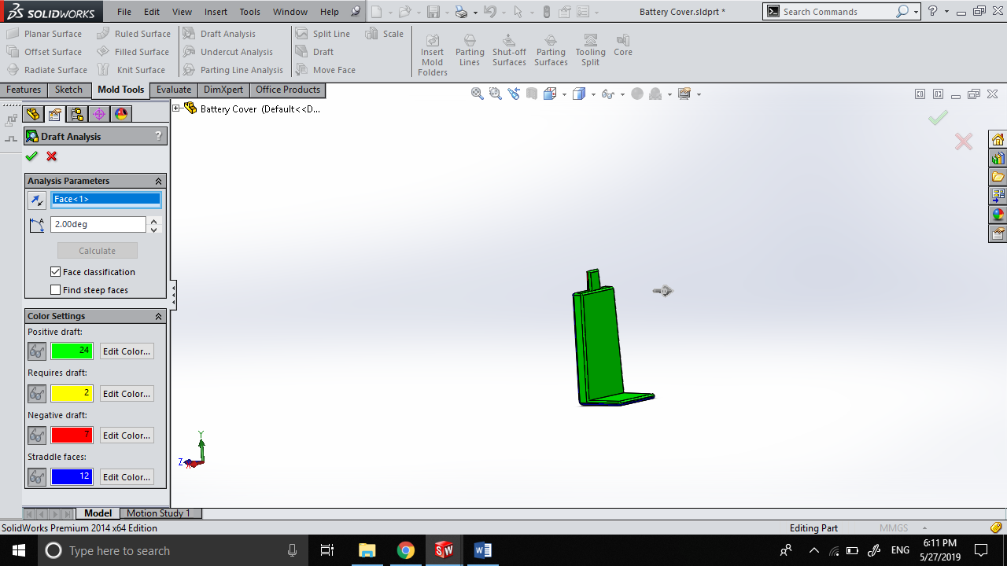

#### Mold Components

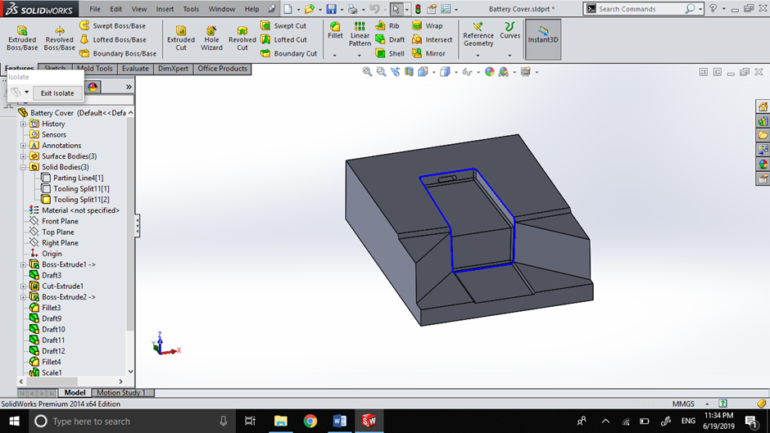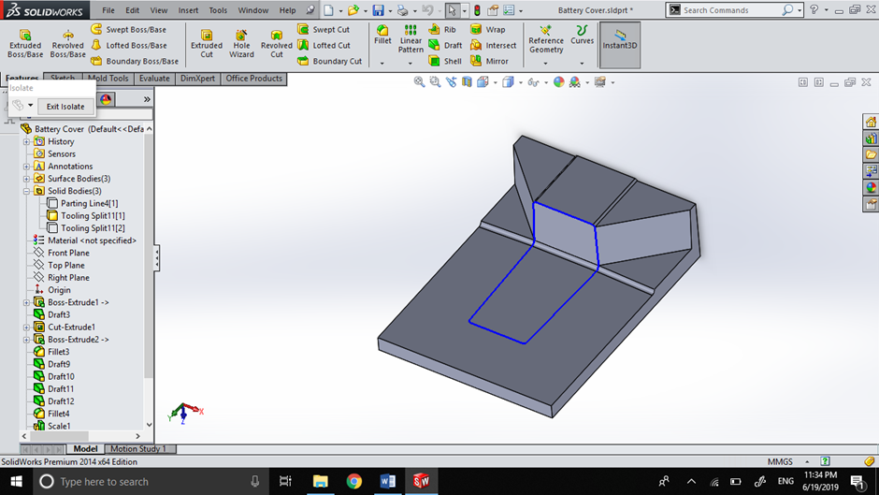

Core

Cavity

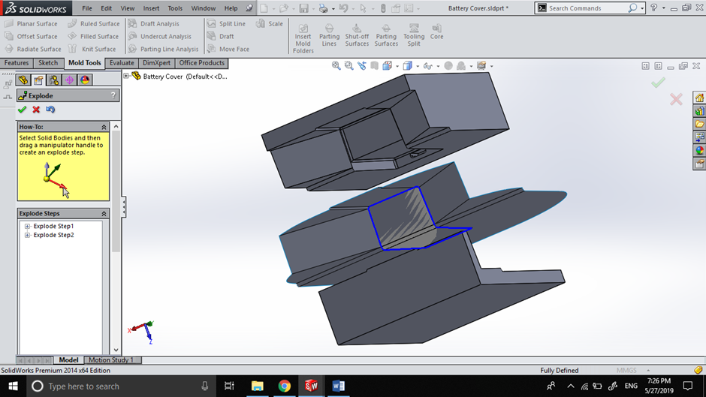

Exploded View of Mold

### Battery Lock

#### Draft Analysis

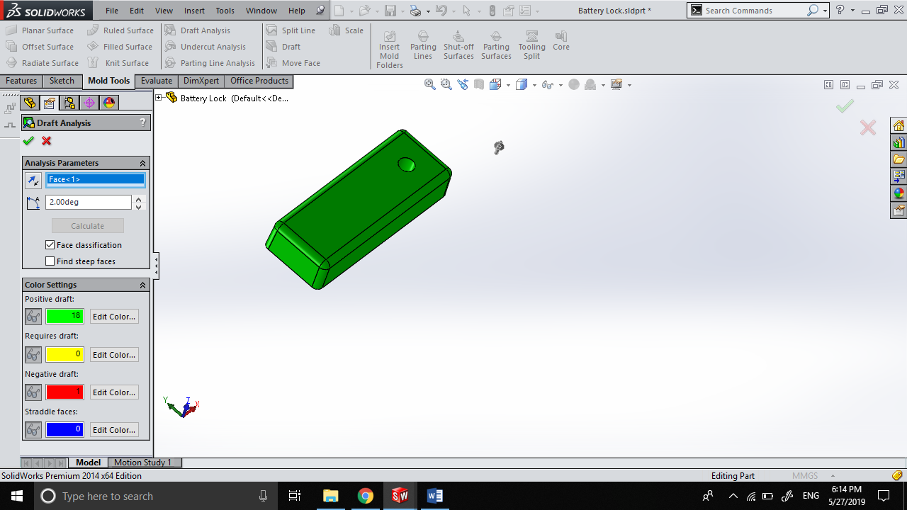

# Display Unit Manufacture

# Sensor Unit PCB Manufacture

## Bill of Materials



### External Component Bill of Materials

|  |  |  |
| --- | --- | --- |
| Component Name | Manufacturer | Quantity |
| ATMega32A | Microchip | 1 |
| DHT11 | AdaFruit | 1 |
| TEMT6000 | AdaFruit | 1 |
| Soil Moisture Sensor | AdaFruit | 1 |
| Rocker Switch | NTE Electronics | 1 |
| 433 MHz Transmitter | AdaFruit | 1 |

## Circuit Schematics









### Circuit Layout

Top Layer Solder mask Top Layer Silk Screen

### PCB Manufacture Additional Information





### PCB Testing Information



# Display Unit PCB Manufacture

## Bill of Materials



### External Component Bill of Materials

|  |  |  |
| --- | --- | --- |
| Component Name | Manufacturer | Quantity |
| ATMega32A | Microchip | 1 |
| Rocker Switch | NTE Electronics | 1 |
| 433 MHz Receiver | AdaFruit | 1 |
| SD Card Reader | Kingston | 1 |
| 16x2 LCD | XIAMEN AMOTEC | 1 |
| 4x4 Keypad | XIAMEN AMOTEC | 1 |

## Circuit Schematics













### Circuit Layout

 Top Layer Solder mask

 Top Layer Silk Screen

### PCB Manufacture Additional Information





### PCB Testing Information



# Sensor Unit Assembly

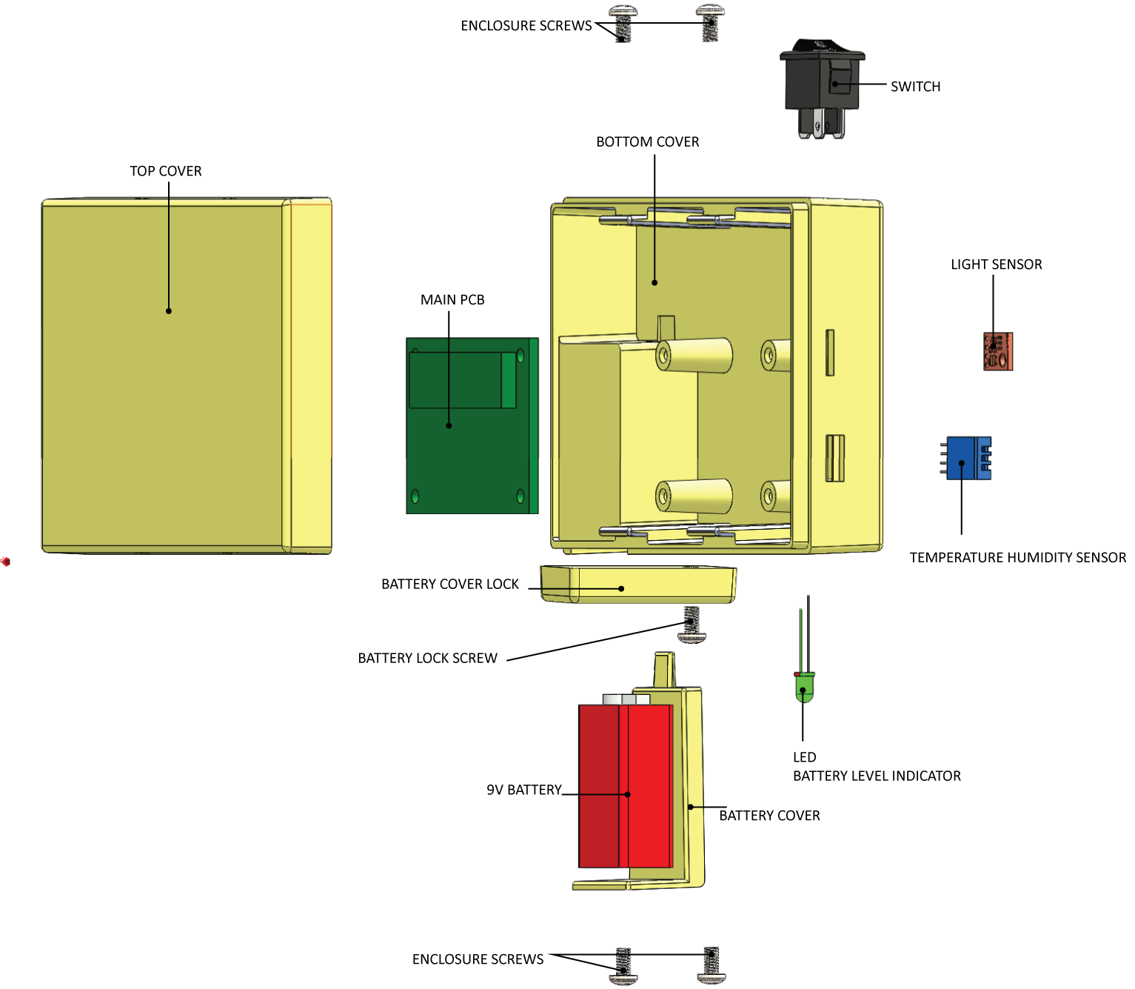

## Assembly Steps

1. Connect the LCD’s to the corresponding headers on the PCB (Refer Circuit Diagram).
2. Insert and secure the LCD’s into corresponding sockets
3. Mount the Fully soldered and tested PCB on the corresponding mounting holes
4. Insert screws and secure the PCB
5. Insert the Temperature, RH, Light and Soil Moisture Sensors into their corresponding sockets and secure.
6. Connect the above sensors using their corresponding polarized headers (See Circuit Diagrams for more information)
7. Insert the rocker switch and secure the battery connector in their corresponding positions.
8. Connect the rocker switch and battery connector to the corresponding places on the PCB
9. Insert the Battery Cover into the Battery Cover slot
10. Screw the Battery Lock into position, and rotate clockwise to secure the battery cover
11. Fit the top cover into position and secure the sides with screws.

# A picture containing screenshot Description automatically generatedDisplay Unit Assembly

## Assembly Steps

1. Connect the LCD’s to the corresponding headers on the PCB (Refer Circuit Diagram).
2. Insert and secure the LCD’s into corresponding sockets
3. Mount the Fully soldered and tested PCB on the corresponding mounting holes
4. Insert screws and secure the PCB
5. Connect the SD card Reader to the corresponding connector on the PCB and insert the SD card reader into its corresponding position and secure.
6. Insert the rocker switch and secure the battery connector in their corresponding positions.
7. Connect the rocker switch and battery connector to the corresponding places on the PCB.
8. Insert the Battery Cover into the Battery Cover slot, and screw into position.
9. Secure the LCD Screen to the inside of the Top Cover.
10. Secure the Keypad to its slot on the top cover, while taking its connector in through the front slot.
11. Connect both LCD and Keypad to the PCB in their correct positions.
12. Fit the top cover into position and secure the sides with locking screws.